Chester Area School

Kristi Philips
CTE 792
Dec. 11, 2006
Instructional Manual

Uploading Assignments to WebCT

CTE 792
Final Project
Paperless classroom
Kristi Philips
December 6, 2006

My final project is to create a paperless classroom. The first step for me will be to ask our technology administrator to add me to the e-mail list that is in our copy machine. Once I am added to the list, I will be able to make a copy of an assignment (worksheet) in the office and it will automatically be sent to my computer through e-mail. After I have the assignment in my e-mail, I can save it into my files. Finally, I can open webCT, click on the assignment file under Physical Science, add a file, browse for a file, find the assignment and download it onto WebCT. Now all of my students should be able to access their assignments at school, or at home. No more lost worksheets or forgetting them at home. If they have their computer, they will have their assignment.

I will be leading an in-service for all teachers at Chester Area School. During the in-service, I will be explaining how to upload information on WebCT. We will also discuss issues involved with using WebCT as a way to create a “paperless classroom”. I will be making copies of my training manual prior to the in-service and then we will be going through them step by step together.

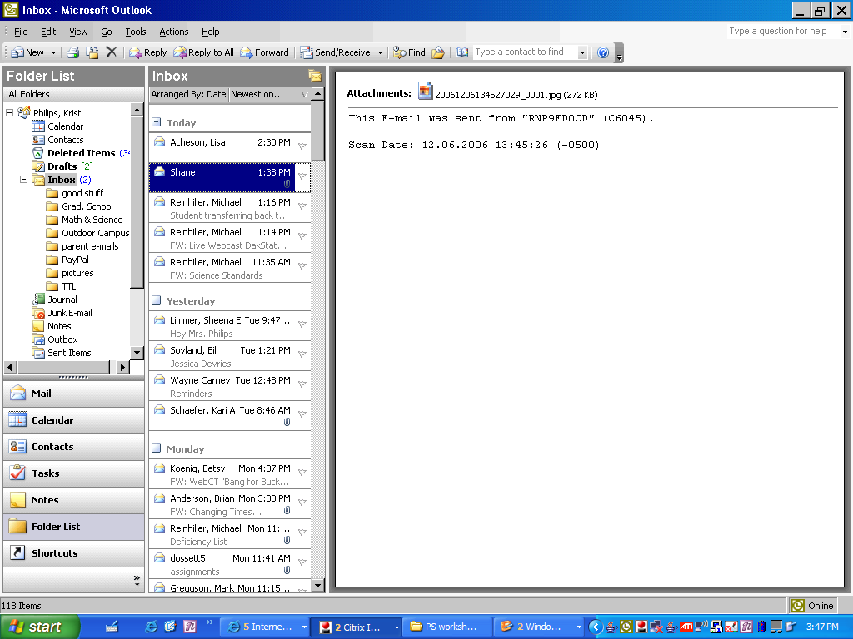
Step 1: Scan a copy of the assignment in the main office copy machine. Send a Copy of the image to your own e-mail address.

Step 2: Return to your own computer and open the image through your e-mail.

Step 3: Right click on the attachment – rename the image and save into the file of your choice.
Example: U: Drive
Philipsk
Physical Science
PS worksheets

Step 4: Select the assignment from the saved file, and PRINT to Journal Note Writer
* So that the students are able to write on the file.

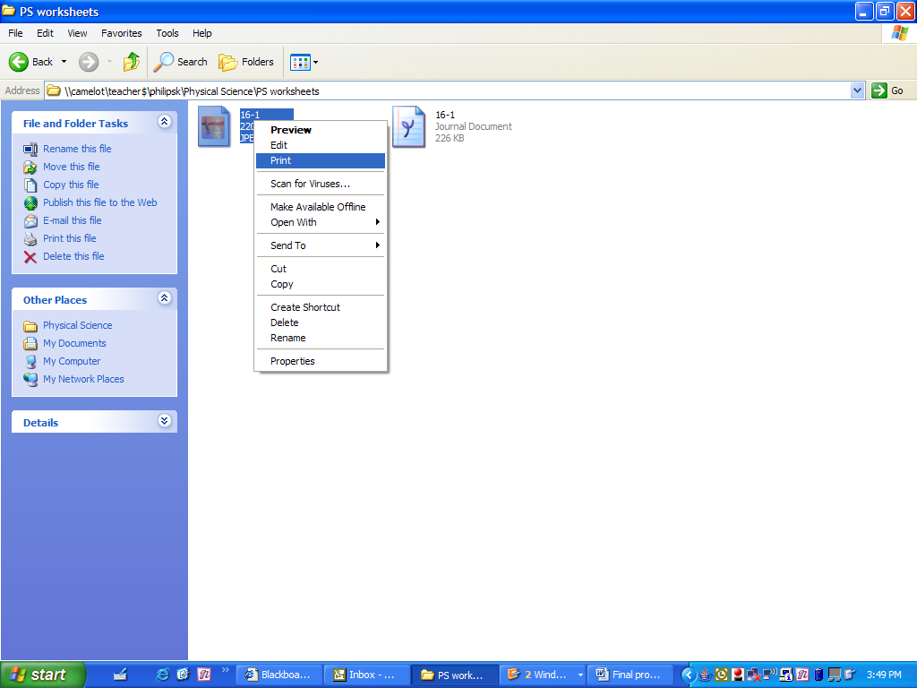

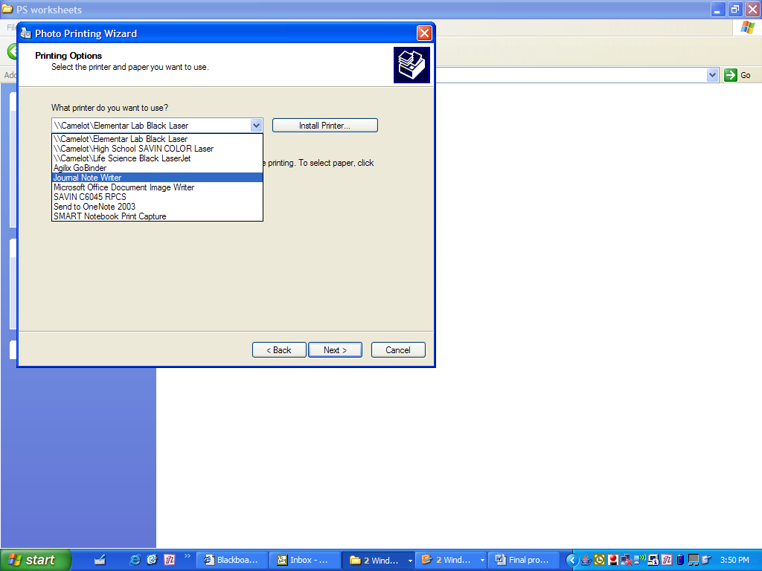

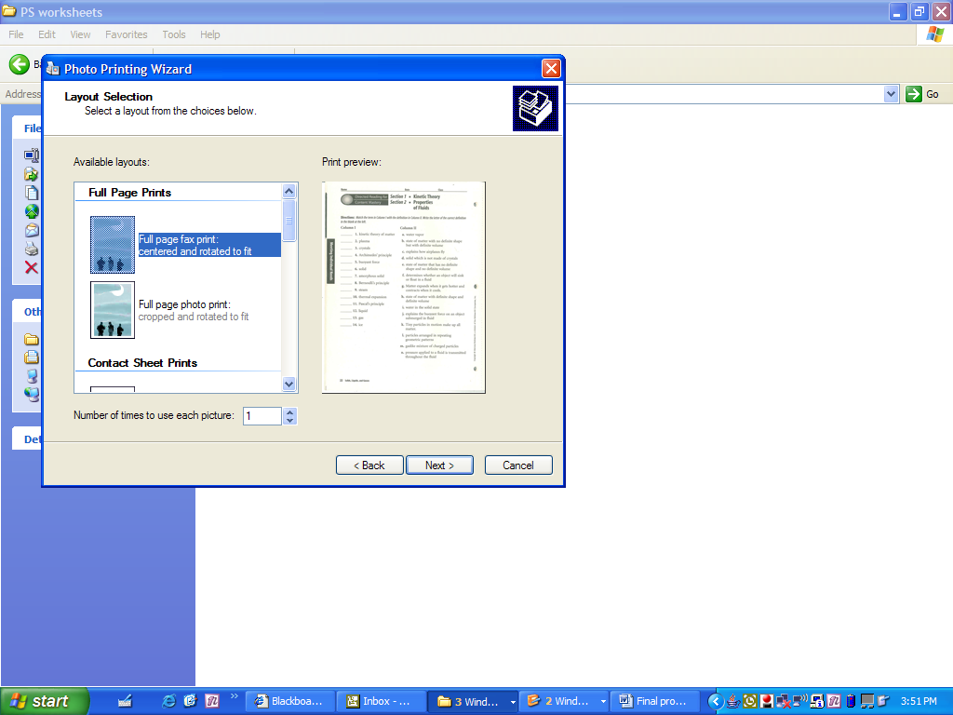

Step 5: Select full page fax print

Step 6: Save assignment as Windows Journal Note
* Now you should have 2 versions of the same assignment in your folder.

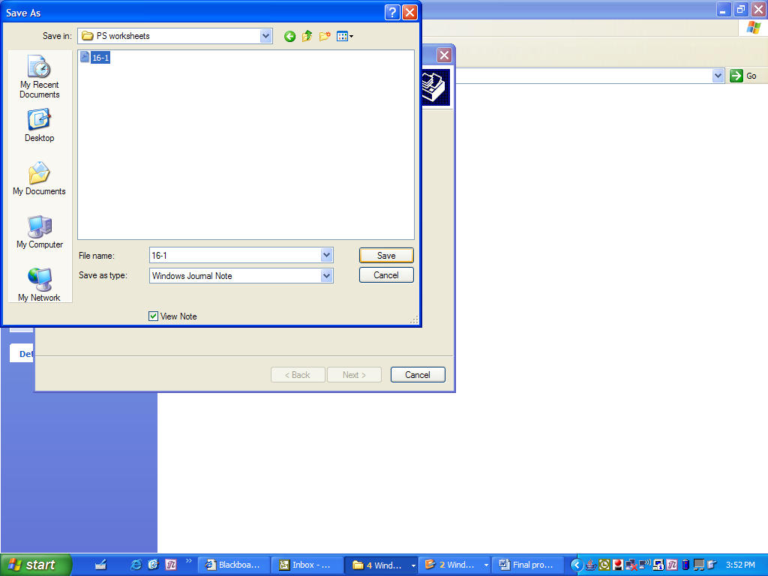

Step 7: This view shows the assignment that I have saved.

The next series of steps will explain how to upload the saved assignment on WebCT.

Step 1: Log onto WebCT
Step 2: Select the class that you are working with.
Make sure you are in BUILD mode
Step 3: Select “ADD a FILE”
Browse for file

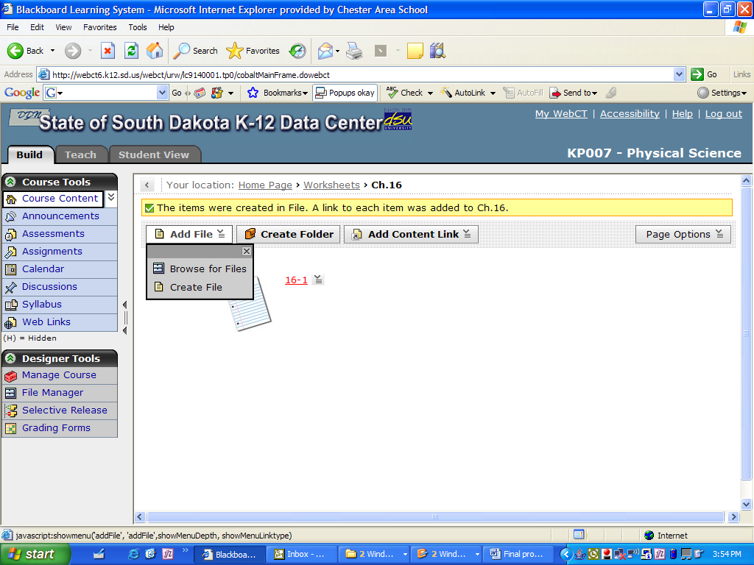

Step 4: Search in My computer.
Step 5: Select the assignment that is saved as a Journal Note.
Double Click and it will be added to your WebCT

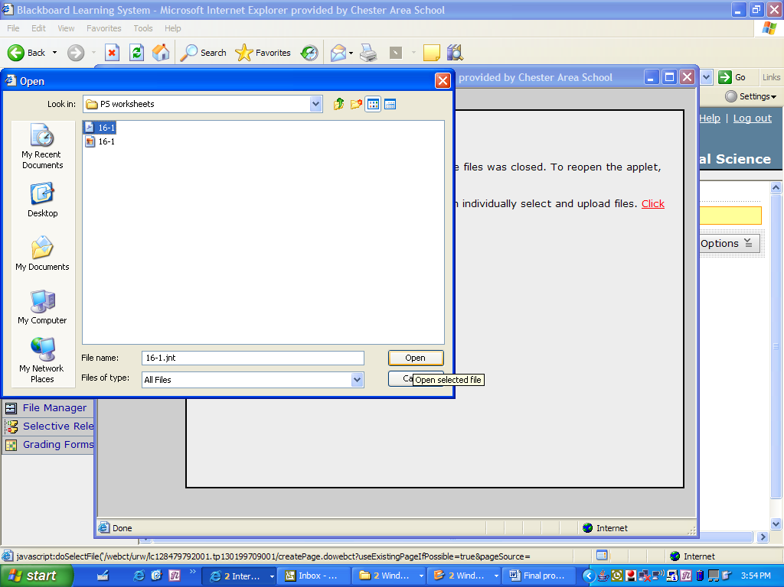

This is the first step for the students to retrieve their assignment.
The students are very familiar with how to use this procedure.
